Lab No. 07

STL Container Adaptors:

Stack & Queue
Task 1: Comparing Stacks & Queues [5+5+5=15]
Part A: Compare Two Stacks [05]
Two stacks of the same type are the same if they have the same number of elements and their elements at the corresponding positions are the same. Write and template based function isStacksSame, which takes two stacks as input, compares them and return, true if both stack are equal, false otherwise.
Code:
#include <stack>
using namespace std;
template <typename T>
bool isStacksSame(stack<T> s1, stack<T> s2)
{
// Check size frst
if (s1.size() != s2.size())
return false;
// Compare ele
while (!s1.empty())
{
if (s1.top() != s2.top())
return false;
s1.pop();
s2.pop();
}
return true;
}
Part B: Compare Two Queues [05]
Two queues of the same type are the same if they have the same number of elements and their elements at the corresponding positions are the same. Write a template-based function isQueuesSame, which takes two queues as input, compares them, and returns true if both queues are equal, false otherwise.
Code:
#include <queue>
using namespace std;
template <typename T>
bool isQueuesSame(queue<T> q1, queue<T> q2)
{
if (q1.size() != q2.size())
return false;
while (!q1.empty())
{
if (q1.front() != q2.front())
return false;
q1.pop();
q2.pop();
}
return true;
}
Part C [05]
Create two stacks and queues in main function and demonstrate working of both above created functions. You can populate stacks and queues with some random values.
Code:
#include <iostream>
#include <stack>
#include <queue>
using namespace std;
template <typename T>
bool isStacksSame(stack<T> s1, stack<T> s2)
{
if (s1.size() != s2.size())
return false;

while (!s1.empty())
{
if (s1.top() != s2.top())
return false;
s1.pop();
s2.pop();
}

return true;
}
template <typename T>
bool isQueuesSame(queue<T> q1, queue<T> q2)
{
if (q1.size() != q2.size())
return false;

while (!q1.empty())
{
if (q1.front() != q2.front())
return false;
q1.pop();
q2.pop();
}

return true;
}
int main()
{
stack<int> s1, s2;
queue<int> q1, q2;
s1.push(1);
s1.push(2);
s1.push(3);
s2.push(4);
s2.push(20);
s2.push(3);
q1.push(10);
q1.push(80);
q1.push(30);
q2.push(10);
q2.push(20);
q2.push(30);
if (isStacksSame(s1, s2))
cout << "Stacks are equal" << endl;
else
cout << "Stacks are not equal" << endl;
if (isQueuesSame(q1, q2))
cout << "Queues are equal" << endl;
else
cout << "Queues are not equal" << endl;
return 0;
}
Output:
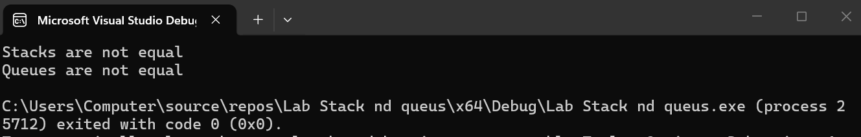
Task 2: Reverse Stack & Queue [5+5+5=15]
Part A [05]
Write a function template, reverseStack, which takes a stack object as input parameter and uses a queue object to reverse the elements of the stack.
Code:
#include <stack>
#include <queue>
using namespace std;
template <typename T>
void reverseStack(stack<T>& s)
{
queue<T> q;
// move all ele frm stack to quee
while (!s.empty())
{
q.push(s.top());
s.pop();
//mve ele back frm quue to stack
while (!q.empty())
{
s.push(q.front());
q.pop();
Part B [05]
Write a function template, reverseQueue, which takes a queue object as input parameter and uses a stack object to reverse the elements of the queue.
Code:
#include <queue>
#include <stack>
using namespace std;

template <typename T>
void reverseQueue(queue<T>& q)
{
stack<T> s;
//mve all ele frm queue to stack
while (!q.empty())
{
s.push(q.front());
q.pop();
}
// move ele back frm stack to queue
while (!s.empty())
{
q.push(s.top());
s.pop();
}
}
Part C [05]
Create a stack and a queue in the main function and demonstrate the working of both the above-created functions. You can populate the stack and queue with some random values.
Code:
#include <iostream>
#include <stack>
#include <queue>
using namespace std;
template <typename T>
void reverseStack(stack<T>& s)
{
queue<T> q;
// Stack / Que
while (!s.empty())
{
q.push(s.top());
s.pop();
}
// Que / Stack
while (!q.empty())
{
s.push(q.front());
q.pop();
}
}
// rverse Quee using Stck
template <typename T>
void reverseQueue(queue<T>& q)
{
stack<T> s;
// Queeee to Stack
while (!q.empty())
{
s.push(q.front());
q.pop();
}
// Stack to Queee
while (!s.empty())
{
q.push(s.top());
s.pop();
}
}
int main()
{
stack<int> s;
queue<int> q;
s.push(5);
s.push(15);
s.push(25);
q.push(100);
q.push(200);
q.push(300);

reverseStack(s);
reverseQueue(q);
cout << "reversed Stack ";
while (!s.empty())
{
cout << s.top() << " ";
s.pop();
}
cout << endl;
cout << "Reversed Queee ";
while (!q.empty())
{
cout << q.front() << " ";
q.pop();
}
cout << endl;
return 0;
}
Output: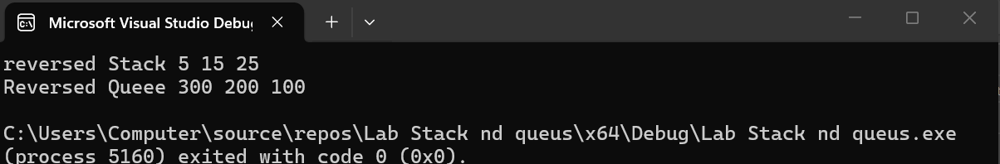
Task 3: Palindrome [10+10=20]
A palindrome is a word, phrase, number, or other sequence of symbols or elements, whose meaning may be interpreted the same way in either forward or reverse direction.
Famous examples include “mom”, “dad”, “123454321” “Amore, Roma”, “A man, a plan, a canal: Panama” and “No ‘x’ in ‘Nixon’ ”, etc.
Part A [10]
Let us try to use stack to evaluate whether a given string is palindrome or not. Write a function isPalindrome, which takes a string as input and returns a Boolean value describing that given string was palindrome or not. (Note: Stack must be used in this algorithm.)
Code:
#include <iostream>
#include <stack>
using namespace std;
bool isPalindrome(string str) {
stack<char> s;
for (int i = 0; i < str.length(); i++) {
s.push(str[i]);
}
for (int i = 0; i < str.length(); i++) {
if (str[i] != s.top()) {
return false;
}
s.pop();
}
return true;
}
int main() {
string word;
cout << "Enter a word ";
cin >> word;

if (isPalindrome(word)) {
cout << "It is a Palindrome." << endl;
}
else {
cout << "It is NOT a Palindrome." << endl;
}
return 0;
}
Output:

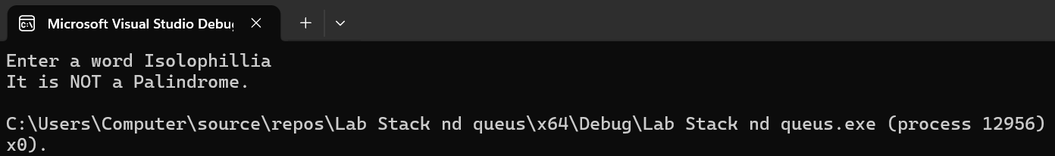
Part B [10]
You are given a text file ‘lab7task3.txt’, which contains different sentences on each line. Read that text file in the main function and use the above-created (i.e. isPalindrome) function to check whether each sentence is a palindrome or not. You have to write the output to another text file.
Code:
#include <iostream>
#include <fstream>
#include <stack>
#include <cctype>
#include <string>
using namespace std;
bool isPalindrome(string str) {
stack<char> s;

for (int i = 0; i < str.length(); i++) {
if (isalnum(str[i]))
s.push(tolower(str[i]));
}
for (int i = 0; i < str.length(); i++) {
if (isalnum(str[i])) {
if (tolower(str[i]) != s.top())
return false;
s.pop();
}
}
return true;
}
int main() {
ifstream inFile("lab7task3.txt");
ofstream outFile("output.txt");

if (!inFile) {
cout << "Error: Could not open input file!" << endl;
return 1;
}
if (!outFile) {
cout << "Error: Could not open output file!" << endl;
return 1;
}

string line;
while (getline(inFile, line)) {
if (isPalindrome(line)) {
outFile << line << " -> Palindrome\n";
}
else {
outFile << line << " -> Not Palindrome\n";
}
}
inFile.close();
outFile.close();
cout << "Done Check output.txt file." << endl;
return 0;
}

Output: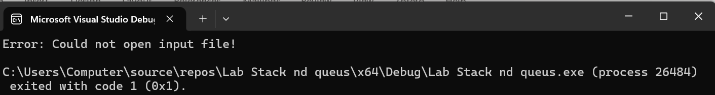
Task 4: Postfix to Infix Conversion [15]
One of the applications of stack is in the evaluation of arithmetic expressions. To evaluate any arithmetic expression we need to convert the infix expression to postfix. Then we evaluate the postfix expression using a stack. Brows Internet to explore what is postfix expression and how it is different from infix expression.
Algorithm for infix to postfix conversion, assuming that there are single digits numbers in infix expression:
0. Define a stack
1. Go through each character in the string
2. If it is between 0 to 9, append it to output string.
3. If it is left brace push to stack
4. If it is operator * + - / then
5. If the stack is empty push it to the stack
6. If the stack is not empty then start a loop:
7. If the top of the stack has higher precedence
8. Then pop and append to output string
9. Else break
10. Push to the stack
11. If it is right brace then
12. While stack not empty and top not equal to left brace
13. Pop from stack and append to output string
14. Finally pop out the left brace.
15. If there is any input in the stack pop and append to the output string.
Write code for the above algorithm and name that function infix2postfix. This function takes a string containing infix expression and a postfix string. Also demonstrate working of infix2postfix function.
Code:
#include <iostream>
#include <stack>
#include <string>
using namespace std;
int precedence(char op) {
if (op == '*' || op == '/') return 2;
if (op == '+' || op == '-') return 1;
return 0;
}
//convert infix to postfix
void infix2postfix(string infix, string& postfix) {
stack<char> s;
postfix = "";

for (int i = 0; i < infix.length(); i++) {
char ch = infix[i];

if (ch >= '0' && ch <= '9') { // if numbr add to postfix
postfix += ch;
}
else if (ch == '(') {
s.push(ch);
}
else if (ch == ')') {
while (!s.empty() && s.top() != '(') {
postfix += s.top();
s.pop();
}
if (!s.empty()) s.pop();
}
else {
while (!s.empty() && precedence(s.top()) >= precedence(ch)) {
postfix += s.top();
s.pop();
}
s.push(ch);
}
}
while (!s.empty()) {
postfix += s.top();
s.pop();
}
}
int main() {
string infix, postfix;
cout << "Enter infix expression (single-digit numbers) ";
cin >> infix;
infix2postfix(infix, postfix);
cout << "Postfix expression" << postfix << endl;
return 0;
}
Output:
